**Q1**: If you have 10 filters that are 3x3x3 in one layer of a convolutional neural network, how many parameters does that layer have?

Ans: Each filter will has 27 + 1 (bias) = 28 parameters. Since this layer has 10 filter so total # of parameters is 28*10=280.

**Q2:**

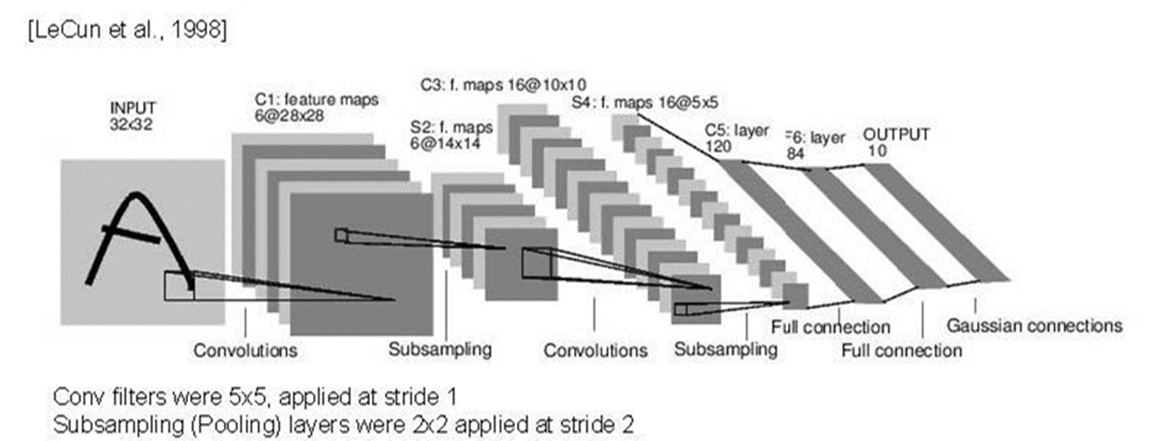

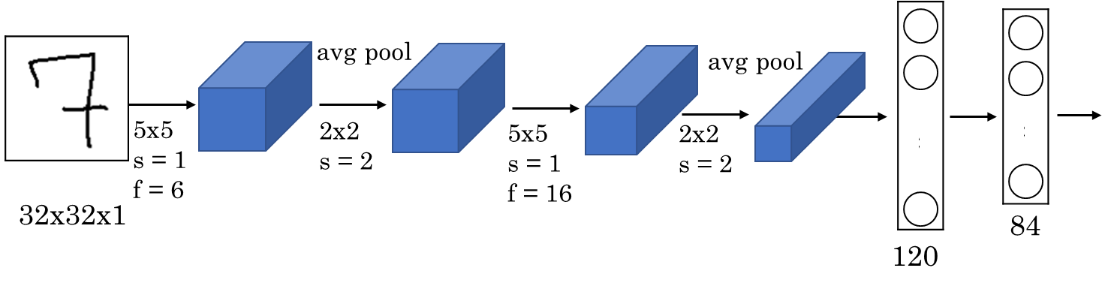

|  |  |  |  |  |  |  |  |
| --- | --- | --- | --- | --- | --- | --- | --- |
| **Layer** | | | | | **Output Volume** | **Total Parameters**  **(with bias)** | **Total Parameters**  **(without bias)** |
| **Name** | **# of Filters** | **Filter size** | **Stride** | **Padding** |  |  |  |
| **Input** | NA | | | | 32x32x1 | NA | NA |
| **Conv1** | 6 | 5x5x1 | 1 | 0 | 28x28x6 | (5x5x1+1)x6 | (5x5x1)x6=150 |
| **Pool1** | NA | 2x2 | 2 | 0 | 14x14x6 | 0 | 0 |
| **Conv2** | 16 | 5x5x6 | 1 | 0 | 10x10x16 | (5x5x6+1)x16 |  |
| **Pool2** | NA | 2x2 | 2 | 0 | 5x5x16 | 0 | 0 |
| **FC3** | NA | NA | NA | NA | 120 | 48120 | 48000 |
| **FC4** | NA | NA | NA | NA | 84 | (120x84)+84 | 120x84 |

**Q3**:

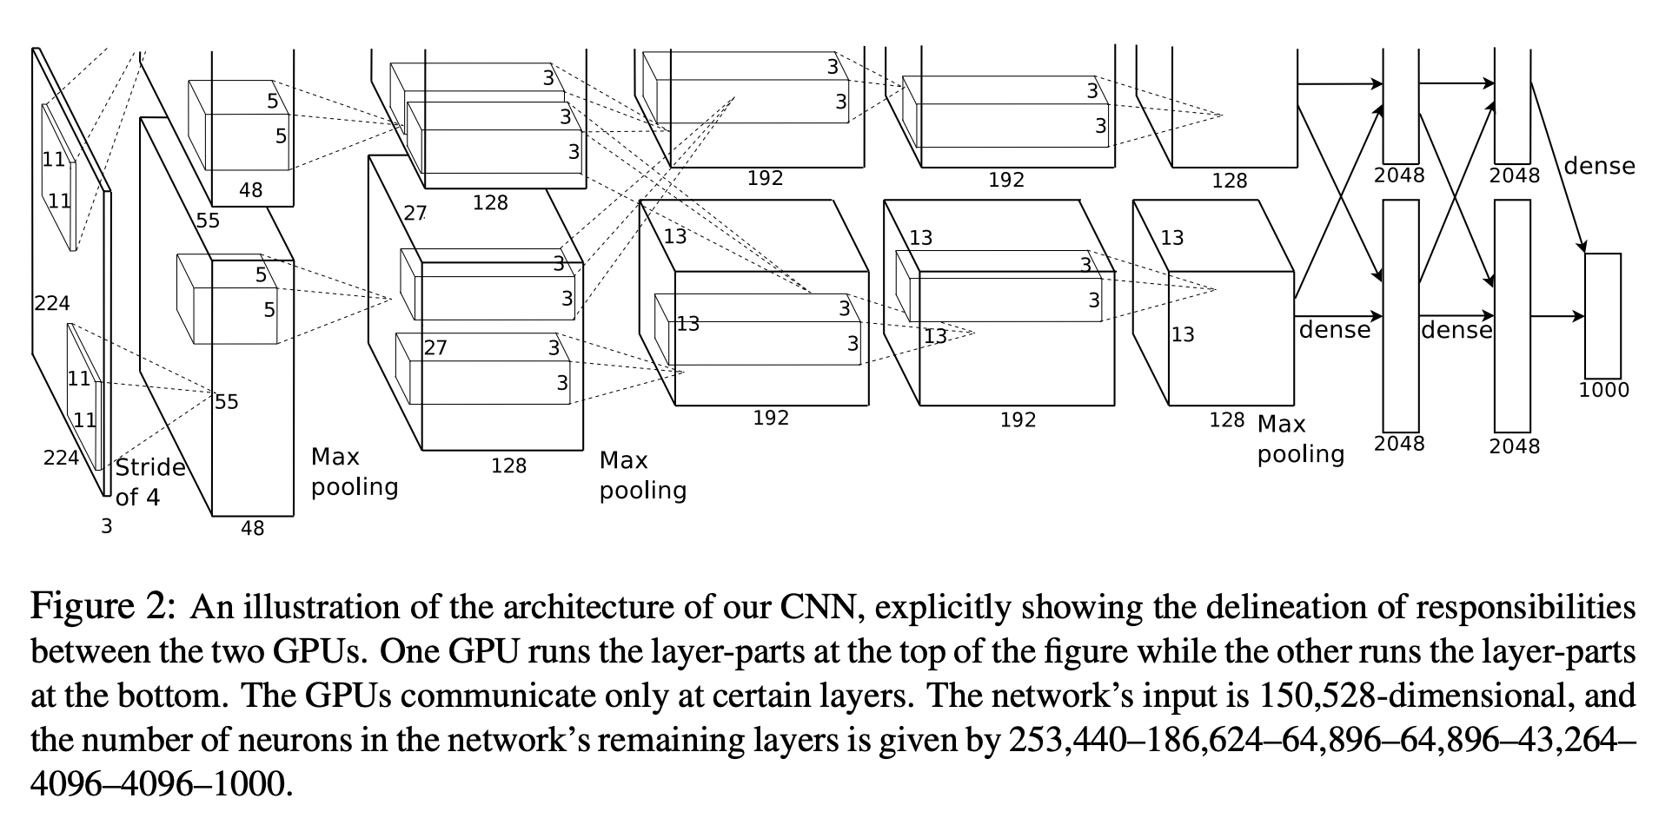

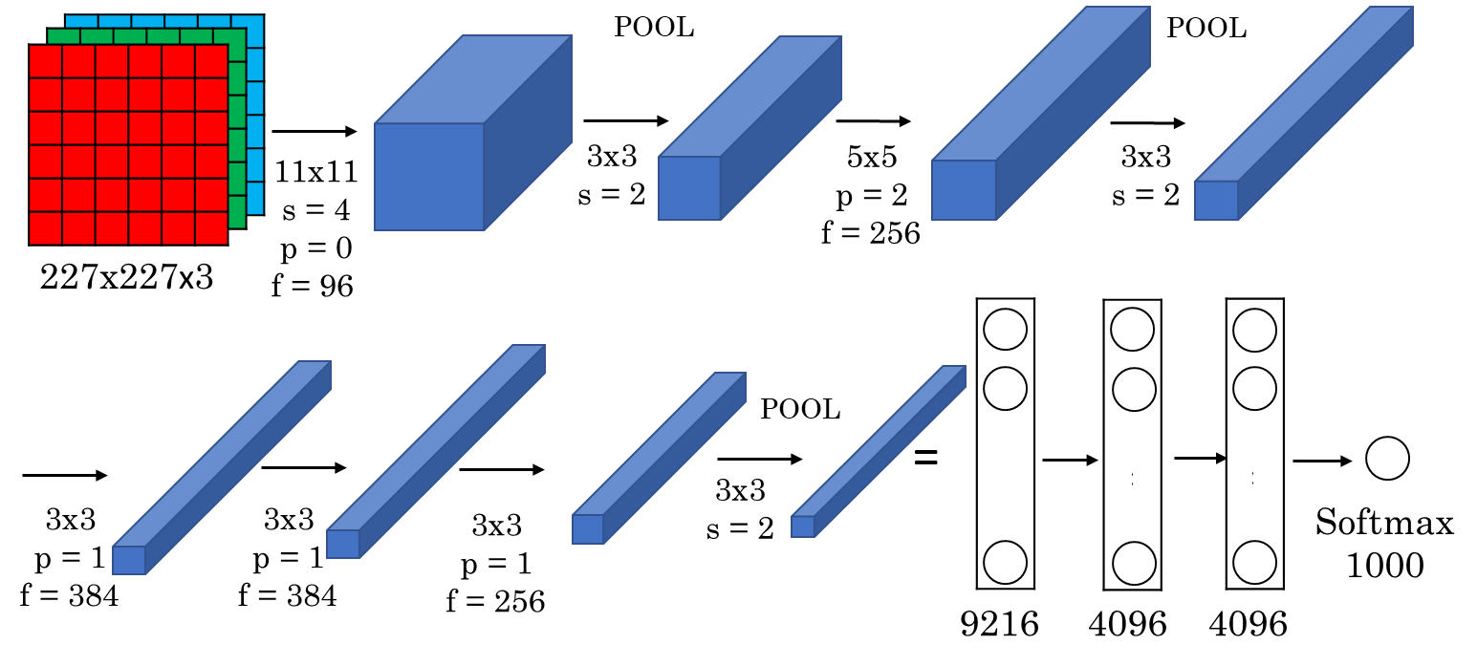

|  |  |  |  |  |  |  |  |  |
| --- | --- | --- | --- | --- | --- | --- | --- | --- |
| AlexNet Network - Structural Details | | | | | | | | |
| Input | Output | Layer | Stride | Pad | Kernel size | In | Out | # of Parameters |
| 227x227x3 | 55x55x96 | Conv1 | 4 | 0 | 11x11x3 |  |  |  |
| 55x55x96 | 27x27x96 | Maxpool1 | 2 | 0 | 3x3 |  |  |  |
| 27x27x96 | 27x27x256 | Conv2 | 1 | 2 | 5x5x96 |  |  |  |
| 27x27x256 | 13x13x256 | Maxpool2 | 2 | 0 | 3x3 |  |  |  |
| 13x13x256 | 13x13x384 | Conv3 | 1 | 1 | 3x3x256 |  |  |  |
| 13x13x384 | 13x13x384 | Conv4 | 1 | 1 | 3x3x384 |  |  |  |
| 13x13x384 | 13x13x256 | Conv5 | 1 | 1 | 3x3x384 |  |  |  |
| 13x13x256 | 6x6x256 | Maxpool5 | 2 | 0 | 3x3 |  |  |  |
| NA | | FC6 |  |  |  |  |  |  |
| FC7 |  |  |  |  |  |  |
| FC8 |  |  |  |  |  |  |
|  | | | | | | | |  |

*In and Out are # of channels in input and output images or feature maps.

**Q4:** Max Pooling: Find the hyperparameters (filter size and stride).

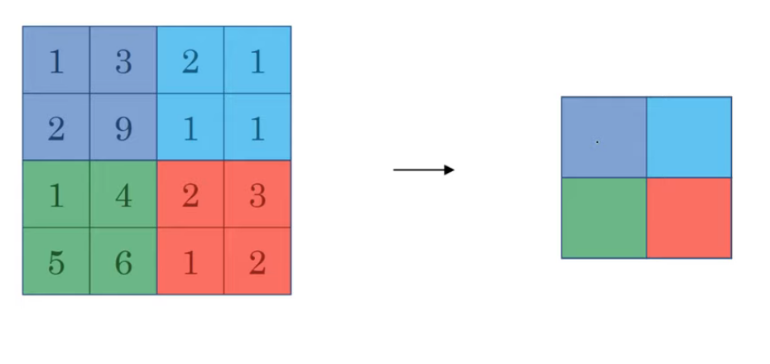

Filter size = 2x2

Stride = 2